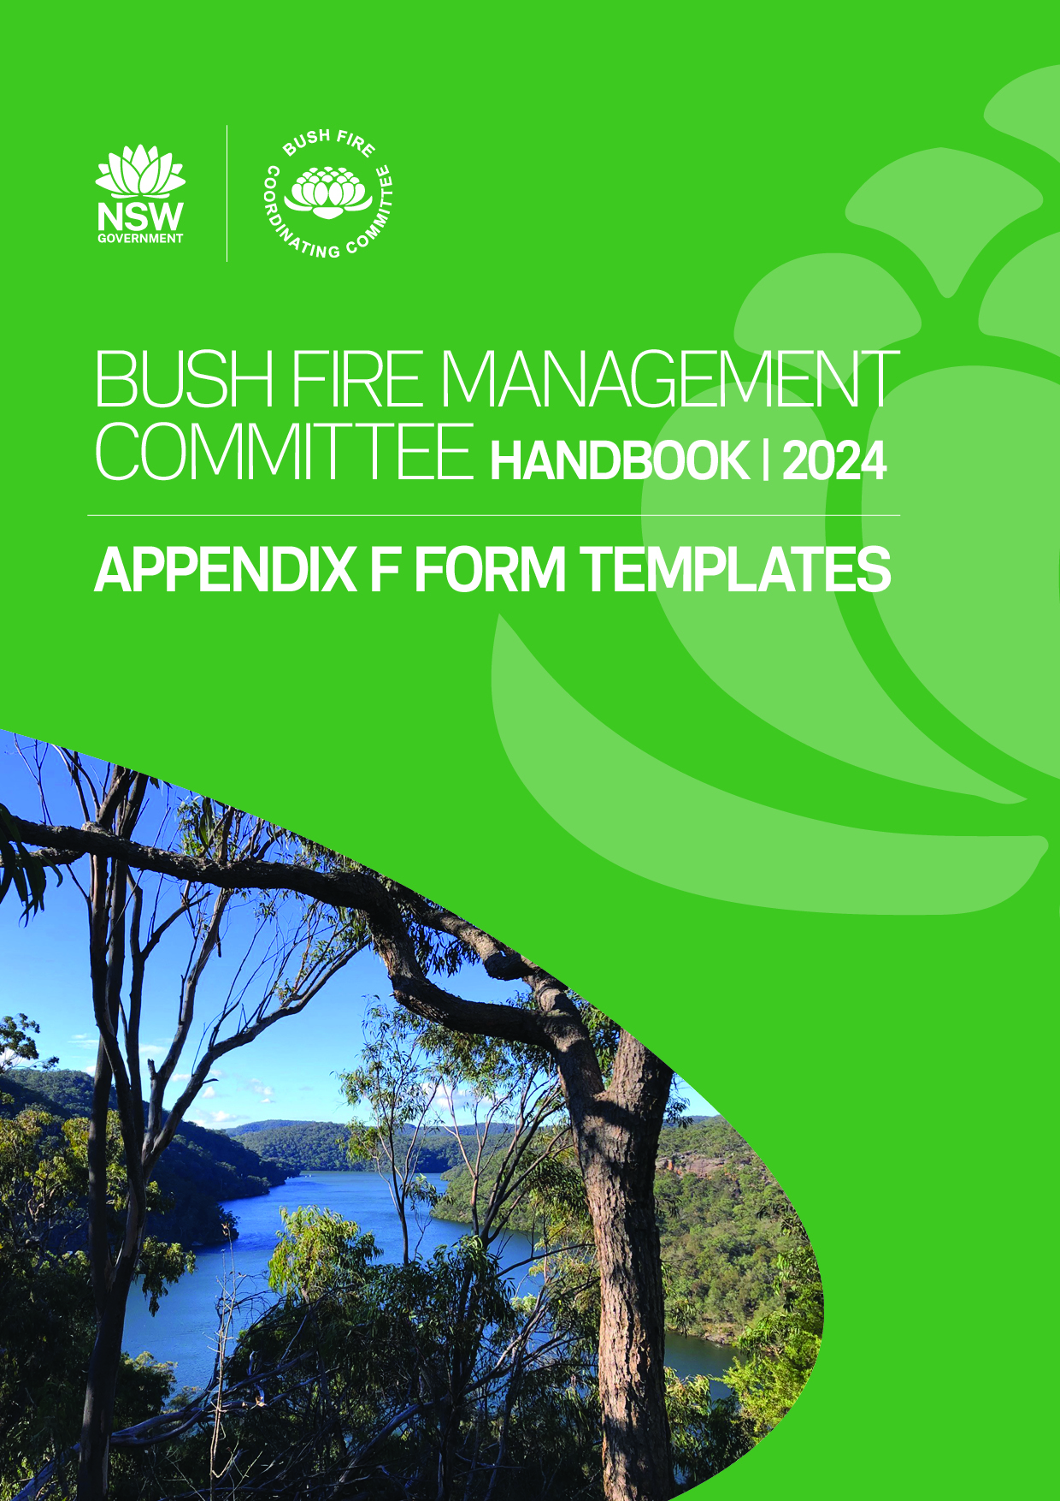

# APPENDIX

**F**

## TEMPLATES

**Contents**

TERMS OF REFERENCE 3

[NAME] BUSH FIRE MANAGEMENT COMMITTEE 5

[NAME] SUBCOMMITTEE OF THE [NAME] BUSH FIRE MANAGEMENT COMMITTEE 6

[NAME] SUBCOMMITTEE OF THE [NAME] BUSH FIRE MANAGEMENT COMMITTEE 8

### TERMS OF REFERENCE

#### [NAME] SUBCOMMITTEE OF THE [NAME] BUSH FIRE MANAGEMENT COMMITTEE

##### ROLE OF THE SUBCOMMITTEE

The [NAME] Subcommittee has been established to carry out the following tasks:

* [INSERT TASK – E.G. PREPARE DRAFT BUSH FIRE RISK MANAGEMENT PLAN]
* [INSERT TASK - E.G. PREPARE DRAFT FIRE ACCESS AND FIRE TRAILS DRAFT PLAN]

This subcommittee may also be requested by the BFMC to investigate and provide advice on specific matters relevant to the above tasks.

##### Membership

Membership of the [NAME] Subcommittee is outline below. At least one BFMC member must be represented on the subcommittee to oversee its activities.

##### Table 1: Membership of the [ NAME ] Subcommittee

|  |  |  |  |
| --- | --- | --- | --- |
| Name | BFMC Member or BFMC Organisation Representative | Organisation | Contact Details |
| [CONVENOR] | [MEMBER OR REP.] | [ORGANISATION] | [CONTACT] |
|  |  |  |  |
|  |  |  |  |
|  |  |  |  |
|  |  |  |  |
|  |  |  |  |
|  |  |  |  |
|  |  |  |  |
|  |  |  |  |

##### Meetings

Members of the [NAME] subcommittee will meet on a regular basis to address matters that have been

referred to it by the BFMC. Dates of meetings are to be determined at the start of each year in consultation with subcommittee members.

A minimum of two weeks notice should be provided if meeting dates change or additional meetings are added.

##### Reporting

Following each meeting of the [NAME] subcommittee, a summary report is to be prepared by the Convener   
and submitted to the BFMC at its next meeting.

The report must include a copy of the agenda(s), minutes and any relevant documents tabled at the subcommittee meeting.

Where a recommendation is to be made by the subcommittee for BFMC consideration, a separate paper is to be prepared by the Convener.

### [NAME] BUSH FIRE MANAGEMENT COMMITTEE

##### [AGENDA ITEM ###]

##### [NAME] SUBCOMMITTEE PROGRESS REPORT

[To note]

Purpose:

Recommendation:

1. That the  BFMC NAME BFMC receives and notes the  SUBCOMMITTEE NAME subcommittee Progress Report.

Background:

[To note]

Current Position:

Add attachment information here

Attachment(s):

Name:

[TITLE]

[NAME]

Title:

[CONTACT NUMBER]

Contact number:

### [NAME] SUBCOMMITTEE OF THE [NAME] BUSH FIRE MANAGEMENT COMMITTEE

##### AGENDA

Meeting:

Convened by:

PLACE, ORGANISATION

[MEETING No. / YEAR]

Location:

NAME, ORGANISATION

[CONVENOR NAME, ORGANISATION

Date Time

HH:MM AM/PM

DD/MM/YYYY

Minutes by:

#### AGENDA

##### Table 1: Agenda Items

|  |  |  |
| --- | --- | --- |
| No. | Agenda item | Responsible |
| 1 | Welcome/ Acknowledgement of Country | [CONVENOR] |
| 2 | Apologies |  |
| 3 | Disclosure of Interests | [CONVENOR] |
| 4 | Confirmation of Minutes of  [# / YEAR]  [INSERT # OF LAST MEETING / YEAR]  meeting held [DATE PREVIOUS MEETING: DD/MM/YYYY] | [CONVENOR] |
| 5 | Business arising from previous minutes   1. General 2. Action Items | [CONVENOR] |
| 6 | [INCLUDE ITEMS TO BE ADDRESSED AT THIS MEETING AND ADD ADDITIONAL ROWS AS REQUIRED] |  |
| 7 | Close | [CONVENOR] |

**Next meeting:**  DAY, DATE, TIME

##### Table 2. Open Action Items from the Last Meeting

|  |  |  |  |  |
| --- | --- | --- | --- | --- |
| Ref. | Item Description | Responsible | Due Date | Status |
| [REF] | [ITEM DESC.] | [NAME / ORG] | [DD/MM/YYYY] | [STATUS] |
|  |  |  |  |  |
|  |  |  |  |  |
|  |  |  |  |  |
|  |  |  |  |  |
|  |  |  |  |  |

##### Table 3. Documents to be tabled

|  |  |  |
| --- | --- | --- |
| Item Description | Responsible | Status |
| BFMC Subcommittee Minutes | BFMC Subcommittee | [STATUS] |
| Draft Focus Areas for Bush Fire Risk Management Plan | Convener |  |
| Draft Annual Works Plan | BFMC Subcommittee |  |
| FAFT Plan | BFMC |  |
| [ITEM DESC.] | [NAME / ORG] |  |
|  |  |  |
|  |  |  |
|  |  |  |

### [NAME] SUBCOMMITTEE OF THE [NAME] BUSH FIRE MANAGEMENT COMMITTEE

##### MINUTES

Meeting:

Convened by:

PLACE, ORGANISATION

[MEETING No. / YEAR]

Location:

NAME, ORGANISATION

[CONVENOR NAME, ORGANISATION

Date Time

HH:MM AM/PM

DD/MM/YYYY

Minutes by:

##### Table 1: Attendance Record

|  |  |  |  |  |
| --- | --- | --- | --- | --- |
| Members (alternate): | Organisation | Present | Apology | Absent |
|  | NSW Rural Fire Service |  |  |  |
|  | Fire and Rescue NSW |  |  |  |
|  | National Parks and Wildlife Service |  |  |  |
|  | Forestry Corporation of NSW |  |  |  |
|  | [NAME] Council |  |  |  |
|  | Department of Industry – Crown Lands |  |  |  |
|  | NSW Farmers Association |  |  |  |
|  | Nature Conservation Council |  |  |  |
| Observers / Support | Organisation | Present | Apology | Absent |
|  | NSW Rural Fire Service |  |  |  |
|  | [NAME] Council |  |  |  |

##### Table 2. Documents Referred to in the Meeting

|  |  |  |
| --- | --- | --- |
| Document title | Author | Date |
| BFMC Minutes | [NAME] | DD/MM/YYYY |
| 2024 BFRMP |  |  |
| 2024 FAFT Plan |  |  |

Minutes

|  |  |  |
| --- | --- | --- |
| **Item 1** | Welcomes and Acknowledgement of Country | Chairperson |
|  |  |  |
| **Item 2** | Apologies | Chairperson |
| As outlined above | | |
| **Item 3** | Disclosure of Interests | Chairperson |
|  |  |  |
| **Item 4** | Confirmation of Minutes of #/YEAR [insert # of last meeting /year] meeting held [date previous meeting] | Chairperson |
|  |  |  |
| **Item 5** | Business arising from previous minutes – General and Action Items | Chairperson |

##### Table 3. Action Items From [DATE] Meeting

|  |  |  |  |  |  |
| --- | --- | --- | --- | --- | --- |
| Ref No. | Item Description | Responsible | Due Date | Status | Subcommittee  Update |
|  |  |  |  |  |  |
|  |  |  |  |  |  |
|  |  |  |  |  |  |
|  |  |  |  |  |  |
|  |  |  |  |  |  |
|  |  |  |  |  |  |

Updates have been provided on the following items:

[01/18-3 Action Name ]

Update provided

01/19-1 Action Name

Update provided

|  |  |  |
| --- | --- | --- |
| **Item 5** | Matters that arise | Chairperson |
|  |  |  |
| **Item 6** | Close |  |

##### Table 4. Updated Action Items

|  |  |  |  |  |
| --- | --- | --- | --- | --- |
| Ref No. | Item Description | Responsible | Due Date | Status |
| [REF#] | [ITEM DESC.] | [NAME] | [DD/MM/YYYY] | [STATUS] |
|  |  |  |  |  |
|  |  |  |  |  |
|  |  |  |  |  |
|  |  |  |  |  |
|  |  |  |  |  |

##### Table 5. Next meeting

|  |  |  |  |
| --- | --- | --- | --- |
| Date | Start time | Finish time | Location |
| [DD/MM/YYYY] | [HH:MM AM/PM] | [HH:MM AM/PM] | PLACE, ADDRESS |

