Coupa Supplier Portal- CSP

FAQ (Frequently asked Questions) for Suppliers Feb 2024

**Background**

This page of frequently asked questions (FAQ’s) is a useful guide - a key knowledge base which will help Suppliers with answering the most commonly asked questions around the CSP & Coupa.

**Outline**

Use this guide when you need to find an answer quickly to a question you may have on Coupa or the CSP.

**Supplier: FAQ’s**

What is the Coupa Supplier Portal (CSP)?

The [Coupa Supplier Portal (CSP)](https://success.coupa.com/Suppliers/For_Suppliers/Coupa_Supplier_Portal)is a cloud-based platform, designed specifically for buyers and suppliers to collaborate. Suppliers can use the CSP to update their business details view their purchase orders, manage their catalogues, and check the status of their transactions which will eliminating the need to contact Accounts Payable, Finance or Procurement.

Coupa Icons & Key Terminologies

Refer to the tables below which will help with identifying common terms and Icons that are used in Coupa to improve your user experience.

**Coupa Icons**

|  |  |
| --- | --- |
|  |  |
| **Key Terminologies used in CSP** |  |
|  |  |

What is the difference of “join and respond” and “respond without joining” Coupa?

There are 2 ways you can use the Coupa System to provide your details.

1. **Join and Respond** via the Coupa Supplier Portal (CSP)

Select this option if you want to register as a RFS supplier whilst also maintaining your public profile and look for extra customers that Coupa have.

You will create your business account/profile and can then use various options eg. View PO’s, create invoices & track payments. Most of your data will be prefilled into the SIM form which is then sent to RFS.

After registering, you will have access to your profile.

1. **Respond without Joining**

Select this option if you want to fill in the application form without creating a CSP profile to become a RFS supplier.

Takes you directly to the “Information Request” form by a one-time link – you can complete your company details without any further registration.

If you supply on a one-off basis or are a small business, it might make more sense to select this.

You can respond and send your information to RFS without joining, but joining allows you to update your Coupa Profile info more easily if it ever changes, as well as do things with NSW RFS (and your other buying organisations that use Coupa) like view purchase orders, create invoices, manage POs and invoices, get real-time SMS alerts and much more.

We recommend choosing “Join and Respond” in order to create a reusable profile and better track your interactions with RFS.

How do I register on the Coupa Supplier Portal?

An RFS staff member can initiate the onboarding process. The RFS staff member will complete a “New Supplier Request” on our end with some basic information supplied by you the supplier.

Once this internal form is approved by our Procurement team a “Supplier Information Update” will be automatically triggered from this and sent to the email address provided.

You will receive an email from [do_not_reply@rfsnsw.coupahost.com](mailto:do_not_reply@rfsnsw.coupahost.com) (subject line “**NSW Rural Fire Service Profile Information Request – Action Required**”) follow the instructions in the email in order to fill in all the necessary details.

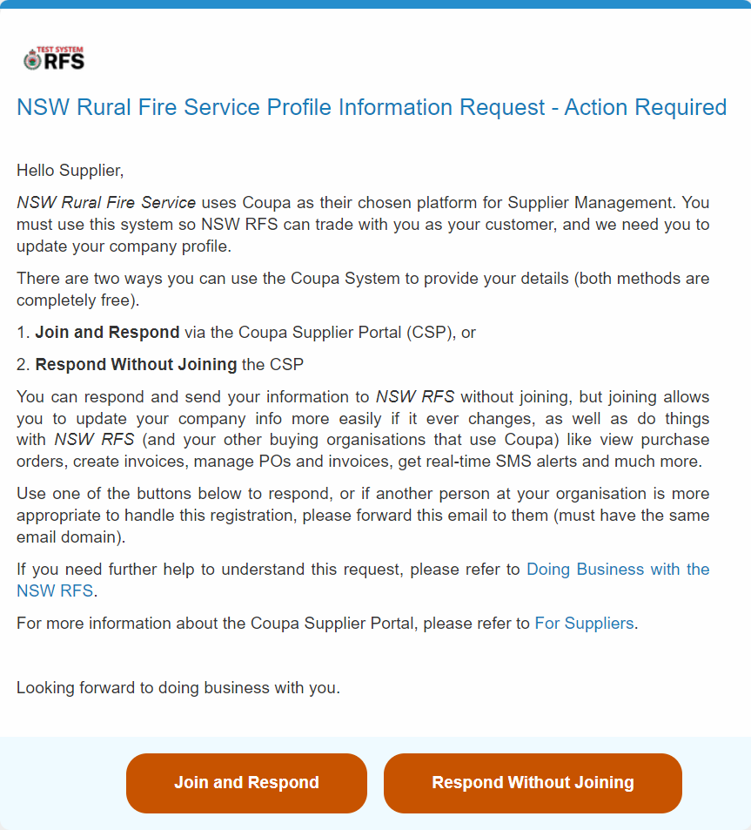

Where can Suppliers find more information about working with Coupa?

For more information about Coupa, suppliers can visit the [Coupa S upplier Page](https://compass.coupa.com/en-us/products/product-documentation/supplier-resources/for-suppliers)

Watch the following tutorials at [CSP videos](https://compass.coupa.com/en-us/products/product-documentation/supplier-resources/for-suppliers/coupa-supplier-portal/csp-videos)

While logged into the CSP - you can also click the **Help** tab for **Help Tour, Blog** and **Online help** this will navigate to the **Coupa Success Portal**

This screen will display after clicking **Help Tour** – click **Next** to view

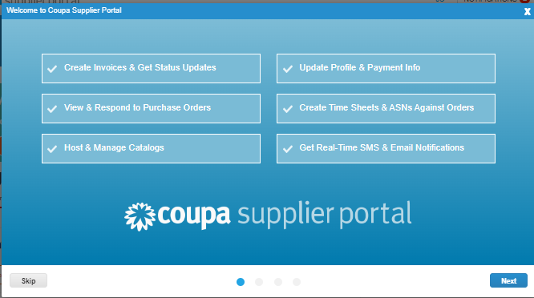

How do I get support for Coupa Supplier Portal (CSP) Issues?

For any Coupa Supplier Portal questions that are RFS related, please contact :-

* RFS Procurement on email [procurement@rfs.nsw.gov.au](mailto:procurement@rfs.nsw.gov.au) phone 8741 5590 or
* RFS Finance on email [finance@rfs.nsw.gov.au](mailto:finance@rfs.nsw.gov.au) phone 8741 4936
* RFS Accounts Payable on email [accountspayble@rfs.nsw.gov.au](mailto:accountspayble@rfs.nsw.gov.au) phone 8741 5163

For general CSP technical or functional support questions that are not RFS related, you can try searching in the [Supplier Help Centre](https://supplier.coupa.com/help/) otherwise if your question is not answered there, then you may contact the Coupa Supplier Support Team at [supplier@coupa.com](mailto:supplier@coupa.com), or you can use their online chat function 24/x5 at supplier.coupahost.com on the bottom right of your window.

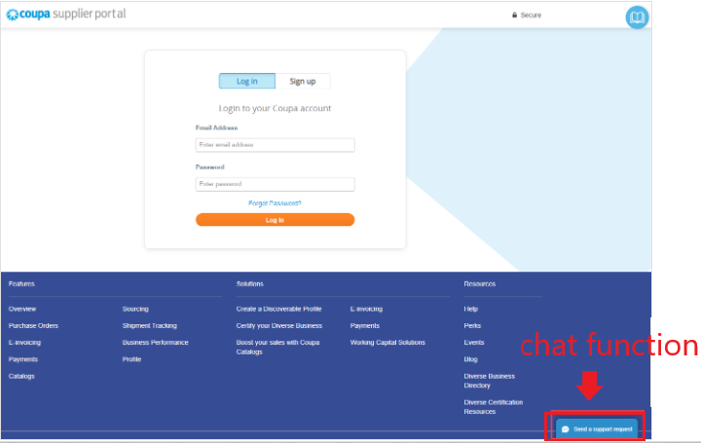

I have been invited to link with the RFS, why is it important to register with Coupa?

The CSP makes managing transactions with RFS easy, this including viewing purchase orders, sending invoices – all in an easy-to-use, self-service platform.

RFS requests that suppliers manage their information in the CSP. Suppliers are encouraged to explore and utilize all the benefits that the CSP has to offer.

The CSP allows you to be in control of your information and view invoice details and payment at any time.

What are the benefits of signing up to the Coupa Supplier Portal?

Unlike other offerings, the Coupa Supplier Portal is FREE for suppliers to use. It is an all-inclusive platform that allows you as a supplier to view your entire RFS relationship. This includes the following functionality:

Monitor and improve visibility on all transactions:

* Purchase Orders
* Invoices
* Credit Notes
* Payments
* Contact details
* Contracts
* Joining sourcing events
* No installation of hardware or software required.
* Connection with the Coupa Community

For more information and benefits for you as a supplier please contact procurement@rfs.nsw.gov.au

Why do I have to complete a Supplier information form in Coupa ?

Completing the registration (SIM - Supplier Information Update) form ensures that RFS have all the required information in Coupa to place purchase orders (PO) and make correct payment of invoices.

How do I log into the CSP?

To log into the CSP – go to [supplier.coupahost.com](https://supplier.coupahost.com/) and in the **Log In** tab, enter your email address and password then click **Login**

Why can’t I log into the CSP?

If you already have a Coupa account set up, check that you have entered your email address and password correctly. If you can’t remember your password, select “Forgot your password?” to request the email to reset your password.

Also, ensure you are not using the browsers auto-populating feature to enter username and password. Try in a different browser.

If you can’t remember what email has been registered for your CSP account – contact RFS Finance on email [finance@rfs.nsw.gov.au](mailto:finance@rfs.nsw.gov.au) and we can look for your company via the **Supplier Portal Directory** and locate the verified admin email and or users.

If using the CSP, who pays me?

Your customer (RFS), who uses Coupa, is still responsible for paying you directly. Coupa does not pay suppliers on behalf of the buyers.

I am registered on the CSP but have forgotten my password, how do I get a new password?

On the CSP log in page, click on “forgot your password?” and enter the email address (verified admin) that is linked to your organisations account and Coupa will send you a link to reset the password.

How much does it cost to join the Coupa Supplier Portal?

**FREE** – there is no charge, the Coupa Supplier Portal (CSP) is a free tool for suppliers to easily do business with their customers who use Coupa.

RFS **does not** require you to make any payment.

If you want to be Coupa Verified and turn Coupa’s customers into yours then this requires a fee.

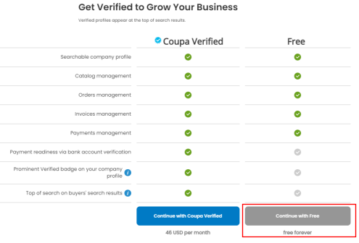

Will you need to download or install software to use the CSP?

No additional software is required. You will only need access to the internet and an email account to access the CSP. The CSP is a cloud base platform.

I have invited a coworker to my CSP account, but they cannot see RFS, what should I do?

Refer to our guide on “How to invite users (Coworkers) & edit users” and you can also go to the Coupa website which provides an article explaining how to set up a new user account and adding users to your account.

Once you have successfully set up new user, you can edit their profile in the admin page and select the customers they need to be connected with.

[Adding users to your Coupa Account](https://supplier.coupa.com/help/setting-up-a-new-customer-account/)

I already have an existing CSP account for another customer. Will I need a second CSP account for the RFS ?

No. If you are already signed up for the CSP as the verified admin, let RFS know the email address you use to log in to the CSP. You can connect with them if you receive an email invite from them and accept their invitation.

Further information is available by simply logging into your current CSP account selecting Profile > Add more Customers setup which takes you to the “How to request to add customer”. You can be doing business with multiple customers from your existing CSP account.

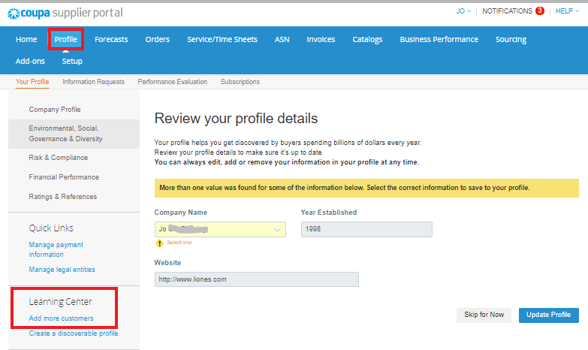

You can also view your customer connections via **Setup tab** then click **Customer Setup.**

If I already have a CSP account and need to see who my customers are – What do I do?

If you are the verified admin of your CSP account, you can go to **Setup** tab then click **Customer Setup.** This will display the list of customers you are connected to.

Our company has more than one CSP account, How can I merge them together?

To Merge accounts – go to the **Setup** tab click **Admin** then **Merge Requests**

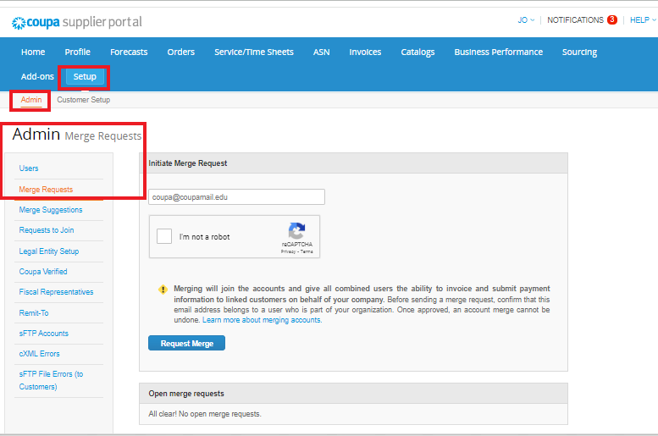

Also refer to our RFS “Coupa_How to Merge Supplier Accounts” and go to the Coupa website - it provides the following article which explains how to merge.

**Please note - once you have merged accounts, this cannot be undone.**

[Manage Merge Requests](https://compass.coupa.com/en-us/products/product-documentation/supplier-resources/for-suppliers/coupa-supplier-portal/set-up-the-csp/account-merges-and-customer-connections/manage-merge-requests)

While completing the onboarding form – I am getting an ISO error?

The state/region ISO code will automatically populate when the state is selected. If you are getting an error here it could be because you are completing the onboarding form on a mobile.

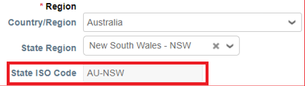

RFS recommend completing this process on a laptop or PC for a better experience. Using a mobile phone limits the page views, and some of the links in the form may not work.

How do I receive and view Notifications in the CSP?

Log in to your CSP account and click on the ‘Notifications’ link in the top right corner. This will open your notifications page. If there is a notification ready for viewing, you will notice a red circle with a number in it showing how many notifications you have. You will also receive a notice by email every time a new notification is added.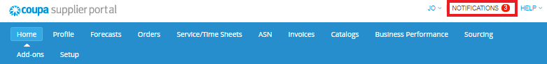

Do I need to register for two factor authentication?

Yes – we recommend that you register. Coupa have added Two Factor authentication as an extra feature & additional security to reduce the risk of fraudulent invoices being submitted to RFS.

When you log in for the first time, you could be prompted to enable two-factor authentication.

If you have enabled the authentication, the Two-Factor Authentication window opens when you want to log in to the CSP.

If you have enabled the App, select open Google authenticator on your device, choose your CSP account and get the validation code.

If you have enabled SMS, check your text messages to get the verification code. Type in the code, you have the option to choose **Remember this computer for 30 days** if you are not using a shared or public computer, and click **Log in.**

|  |
| --- |
| Note – the code is good only for 60 seconds. If you dont type that code on the CSP sign-in page and click Log in within 60 seconds, you have to get a new code and try again |

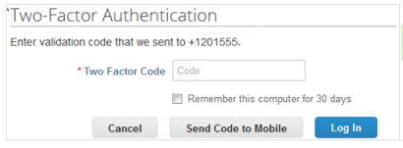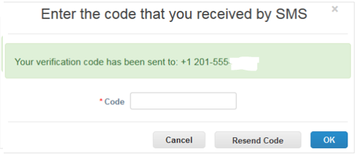

**Enable or Disable Two-Factor Authentication**

On the **My Account** page, click on the **Security and Two-Factor Authentication** link to enable or disable this feature.

For more info see Coupa Compass - [Manage Multi-Factor Authentication](ttps://compass.coupa.com/en-us/products/product-documentation/supplier-resources/for-suppliers/core-supplier-onboarding/get-started-with-the-csp/your-account/manage-multi-factor-authentication)

Why do I keep receiving reminder emails?

We want you to register as a supplier so we can set up a vendor and then organise invoice payment.

When we send you a SIM form to complete you will be reminded several times to complete this information. If you have not submitted your response within a month the form will cancel.

You will have to contact RFS Finance [finance@rfs.nsw.gov.au](mailto:finance@rfs.nsw.gov.au) to have the form resent.

Can I withdraw my Supplier Information update form if I need to adjust some information ?

Yes, while in the **Profile** tab click > **Information Request** this will display the **“Supplier Information Update”** form that you submit.To withdraw **-** scroll to the bottom of the form and select the **Withdraw** button. You will then be able to modify the form before submitting again.

|  |  |
| --- | --- |
|  |  |

How do I view my purchase orders?

Log into your CSP account and select **Orders** from the top menu bar.  Select the ‘PO Number’ to open and view a purchase order.  Purchase orders will be sent to the PO Email address that RFS has on file for your business.

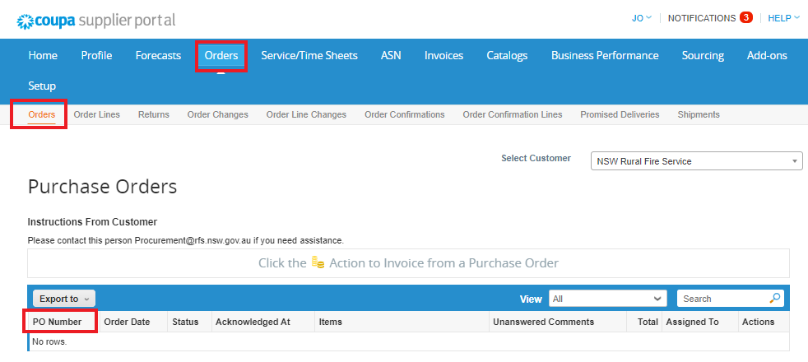

If you wish to change this email address, please contact: [procurement@rfs.nsw.gov.au](mailto:procurement@rfs.nsw.gov.au) or [finance@rfs.nsw.gov.au](mailto:finance@rfs.nsw.gov.au) and we will send you a Supplier Information update form so that you can update these details.

Does my invoice need to reference a Purchase Order?

Yes. All invoices sent to the RFS must reference the Purchase Order that was sent to you by RFS.

Is it necessary to receive a PO number with every purchase request?

Yes. All supply requests MUST include a valid Purchase Order Number.

* RFS will REJECT every invoice which fails to include a valid purchase order number, issued prior to the supply of any products or services.
* RFS Employees MUST provide a valid purchase order number to a Supplier prior to requesting and accepting delivery of any product or service or the employee is in breach of RFS Procurement Policy.

Please report to us an RFS employee who is requesting product or service deliveries WITHOUT FIRST providing you with a valid purchase order number.

Please contact [procurement@rfs.nsw.gov.au](mailto:procurement@rfs.nsw.gov.au)

Why does the Purchase Order number look different?

Due to Operational efficiencies within the RFS, the Purchase Order number may look different depending on a variety of factors. These may include a PO leading with a:

* “B” -Generated as part of Business as Usual (BAU) activity.
* “E” –Generated as part of Emergency activity.
* “45…” –Another order for other specific materials procured by the RFS

How do I view and manage invoices & payments?

Log into your CSP account and from the Home Page select ‘Invoice’ tab.  This will then allow you to see open and view invoices.  You will have the functionality to create Invoices from PO & create Credit Notes. The invoices displayed are the ones that you have created.

To generate a new one, you must enter through the “Orders” tab.

For further assistance please contact [accountspayable@rfs.nsw.gov.au](mailto:accountspayable@rfs.nsw.gov.au)

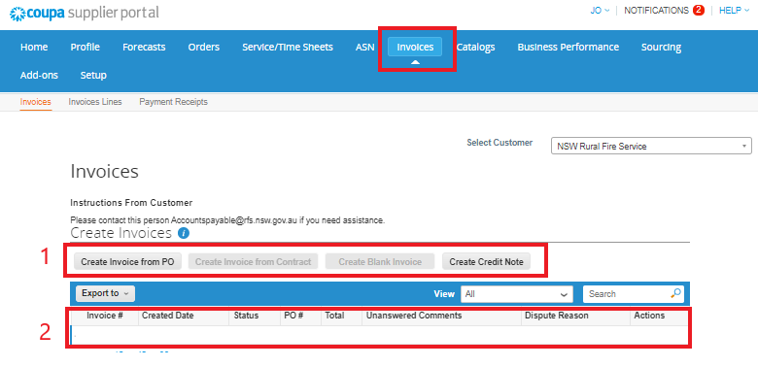

1. You will have the functionality to select buttons –“Create Invoice from PO” and “Create Credit Note”
2. This section will display general Information about the invoices you have created, you will be able to see the invoice number, status, creation date, total etc

On the **Payment Receipts** tab you will be able to view all payments made.

I have paid an amount different from what is on the invoice. How do I rectify this?

The amount mentioned in the Coupa invoice will be paid by RFS, so please ensure that the amount invoiced in Coupa matches your records. You must attach a copy of your invoice with the Coupa-generated online invoice you send RFS.

If you need assistance, then please contact [accountspayble@rfs.nsw.gov.au](mailto:accountspayble@rfs.nsw.gov.au)

How do I enter the tax details in the invoice I send RFS?

When you as a supplier, creates an invoice for RFS payment (the gold coins on the Orders tab), you will be required to populate the details on the invoice including: - invoice number, quantity, price etc.

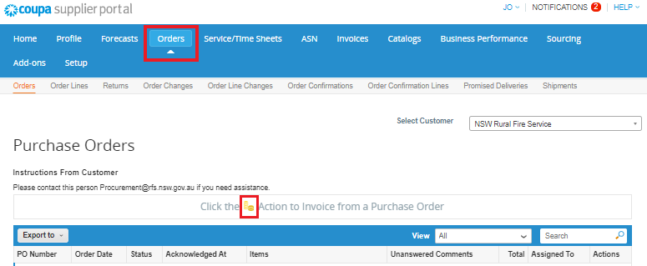

At the line level tax you will also be required to select the correct GST rate that is applicable on this line. Please select GST rate 10%.

Should I send the invoice to RFS via Supplier Actionable Notification (SAN) or process it via the CSP?

As a supplier you can create and send the invoice to RFS either by a Supplier Actionable Notification (SAN) or process it via the CSP. If you have successfully signed up via the CSP, it would be simplest and preferable for you to utilize this platform for transacting with the RFS.

Flipping an invoice is RFS’ preferred method, please ensure invoice figures and attachments are correct, for additional information on how to complete this, please see below.

Option 1 - ***Receiving a PO and flipping the invoice in the Coupa Supplier Portal (CSP)***

If you are linked to the RFS via the Coupa Supplier Portal (CSP), you now have the advantage of managing all transactions with the RFS in one location, including: Purchase Orders, RFS invoices & Credit notes.

To action a PO :

Option 2 - ***Transacting with the RFS without the Coupa Supplier Portal (CSP)***

If you have *not* signed up to the *Coupa Supplier Portal (CSP)*, you will then receive a *Supplier Actionable Notification (or SAN)*–an email message with Actionable buttons.

You will then select **Create Invoice** which will generate a secure online form for you to populate. Once reviewed and ready, select **Send** to complete the transaction.

I would like to change my bank details – what do I do?

If your bank details have change - please request the RFS via email [finance@rfs.nsw.gov.au](mailto:finance@rfs.nsw.gov.au) to send you a request to update your bank info, this form is called “Supplier Information update”. Once you receive this request, please action asap, you can refer to the user guide ‘Coupa_ Supplier Training Quick Guide.pptx’ if you need additional help in completing this form.

I would like to change my businss details – i.e contact phone number – what do I do?

If your phone number has changed - please send an email to RFS Finance email [finance@rfs.nsw.gov.au](mailto:finance@rfs.nsw.gov.au). We can either send you a form called “Supplier Information update” so you can update the details, or we can complete an “Internal Supplier update” form on your behalf if you are registered on the CSP. If not registered on the CSP then we will need you to complete a “Supplier Information update”. Once you receive this request, please action asap, you can refer to the user guide ‘Coupa_ Supplier Training Quick Guide.pptx’ if you need additional help in completing this form.

I would like to change my email address – what do I do?

If your remittance address or PO email address has changed – please send an email to RFS Finance email [finance@rfs.nsw.gov.au](mailto:finance@rfs.nsw.gov.au). We can either send you a form called “Supplier Information update” so you can update the details or we can complete an “Internal Supplier update” form on your behalf if you are registered on the CSP. If not registered on the CSP then we will need you to complete a “Supplier Information update”. Once you receive this request, please action asap, you can refer to the user guide ‘Coupa_ Supplier Training Quick Guide.pptx’ if you need additional help in completing this form.

Our business ABN has changed – what do I do?

If your business structure has change, you may need to cancel your ABN and apply for a new one an example of this is when an Individual/Sole Trader changing to an Australian Private Company, in this instance we will need set up the new ABN as a new vendor and block the old one. We will need to onboard your new Company details as a New supplier in the RFS system.

Each ABN is set up with a unique 6 digit vendor number.

If your ABN Status, Business name, transfer due to adding a partner, GST registration changes or for any other reason – please let RFS know either via your direct contact or by emailing RFS Finance [finance@rfs.nsw.gov.au](mailto:finance@rfs.nsw.gov.au)

We can then decide on what action needs to occur.

|  |  |  |
| --- | --- | --- |
| For further information – go to the [Coupa Supplier Portal](https://success.coupa.com/Suppliers/For_Suppliers/Coupa_Supplier_Portal) or contact Coupa via email [sourcing.support@coupa.com](mailto:sourcing.support@coupa.com) |  |  |